PRESS INFORMATION – 25 JANUARY 2021

MG MOTOR PLANS FURTHER DEALER OPENINGS IN 2021 AS UK’S
FASTEST-GROWING CAR BRAND EXPANDS MARKET PRESENCE

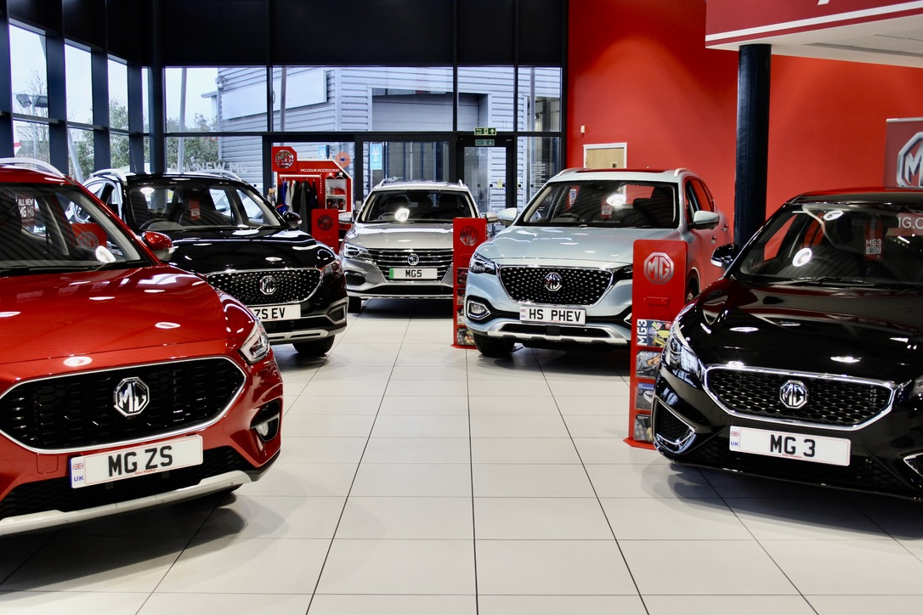

- MG Motor to expand its network to at least 130 dealers by end of 2021
- Move follows 28 new dealers joining the brand in past 12 months
- EV leadership and great value proposition make MG a highly desirable franchise
- MG sales increased by 41% in 2020
- All MGs covered by brand’s famous 7 year warranty

The popularity of the UK’s fastest-growing car brand shows no signs of slowing down as MG Motor gears up to increase its network to at least 130 dealers by the end of 2021.
With a range now encompassing six models and a rapidly growing reputation for offering affordable EVs for everyone, the brand has seen 28 new sites join its network in the past 12 months.
Most recently Glyn Hopkin in Milton Keynes, St Albans and Cambridge, Perrys in Huddersfield, JCT600 in Bradford, Read Motor Group of Grimsby, Drive in Bristol, Hawkins of Hayle, Tunbridge Wells MG and Masters in Croydon have joined the network, expanding the presence of MG in areas of increasing demand.
The dealer network now stands at 120 sites, with at least a further 10 scheduled to open in 2021 as the popularity of MG increases ever further.
MG Motor’s Commercial Director, Guy Pigounakis, said: “Our dealer network is expanding on the back of a record year in which we saw our market share break the crucial 1% barrier and our sales volumes increase by 41%, massively outperforming the market and finishing the year with volumes on a par with some much more established rivals.
“But this doesn’t surprise us. The MG range is perfect for our times – great value cars that are great to drive, packed with technology and backed by a 7-year warranty. MG is also the definitive leader in affordable electric motoring and encapsulates the idea of electric for everyone, something that our dealers – and our customers – can’t get enough of.”
MG currently offers six models in the UK including three plug-in cars – the established MG ZS EV, the game-changing All New MG5 EV and MG HS Plug-in, all backed up by MG’s incredible 7 year warranty and fast-developing dealer network.
To find your local dealer, or to discover the high-tech, value-for-money range of cars on offer, please visit MG.CO.UK.
- ENDS -
Notes to editors:

About MG

Tracing its history back to 1924, MG is the iconic British motoring brand, famous for building sporty, exciting and value-for-money cars which are always fun to drive. From the original MG 14/28 Super Sports car, designed by the legendary Cecil Kimber, to the all-electric MG5 EV of today, MG has always been innovative, always been radical and always been fun!

Today, MG is the fastest growing car brand in the UK, fielding a six-car range of practical and affordable hatchbacks, SWs and SUVs. Designed in Marylebone, London, and manufactured in state-of-the-art factories in several countries, today’s MGs are practical, spacious, packed with technology and perfect for modern life. With a national network of 120 dealerships, MG is accessible to customers everywhere with professional sales and aftersales provision across the UK.

Backed by SAIC Motor, one of the world’s largest automotive companies, all new MGs are built with world-class components and are backed by a comprehensive manufacturer’s 7 year warranty. Well-established in the UK, MGs are now sold worldwide with western Europe being the latest region for expansion during 2020.

For further information please contact:
CRAIG CHEETHAM
MG Press Office
T: +44 7900 085571
E: craig@crccreative.co.uk
www.mg.co.uk

