PRESS INFORMATION – 4 JUNE 2021

BRITAIN’S FASTEST-GROWING CAR BRAND CONTINUES TO BREAK RECORDS

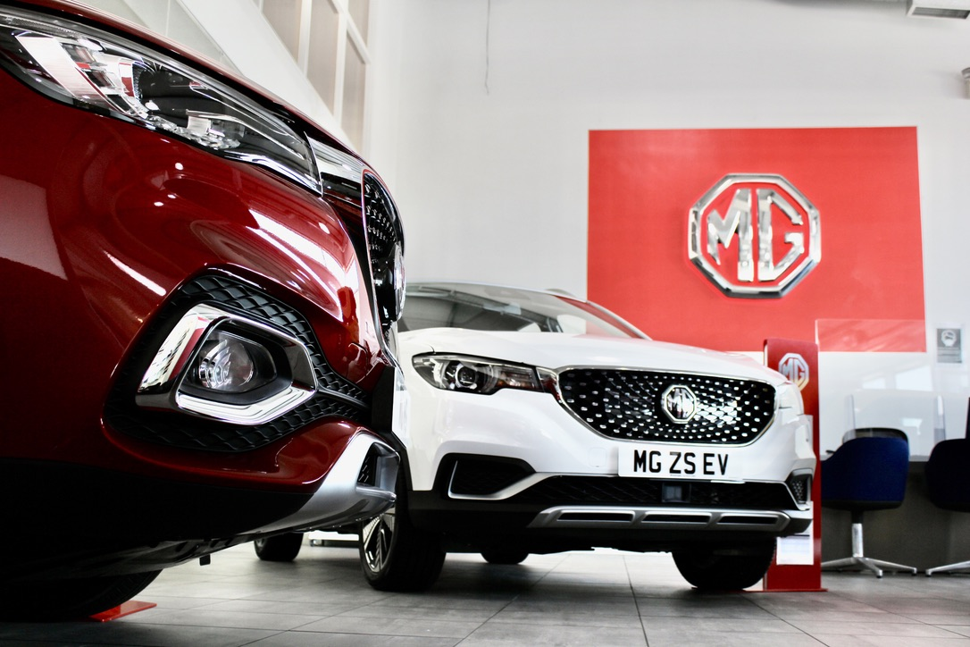

- MG Motor sees 89.2% growth year-to-date
- Total May registrations of 2,453 make May the 4th month MG has achieved over 1.5% market share in 2021
- MG has sold 10,760 cars so far this year – more than in the whole of 2018
- Pure electric models account for 31.7% of volume against an industry average of 7.5%
- All new MGs come with 7-Year Warranty

MG Motor has taken a market share of over 1.5% for the fourth month this year as the brand continues its incredible growth.
The company achieved 2,453 registrations in May 2021, giving it a share of 1.57%. Its total sales in 2021 amounted to 10,760 at month end – a greater number than it sold in the whole of 2018. In addition, more than three in 10 MGs sold (31.7%) were pure electric against an overall market penetration of 7.5% for BEVs across all brands.
Guy Pigounakis, MG’s Commercial Director, said: “So far in 2021, we’ve seen an incredible sales performance from our dealer network, which itself is growing at quite a rate. As we emerge from the stricter part of lockdown, it’s great to see dealerships so busy and a strong appetite for our models from the British car-buying public.
“The EV volumes in particular are fantastic. We are committed to making EVs affordable for everyone and MG is clearly firing the public’s imagination with its combination of great quality, high tech, incredible value and our 7 Year Warranty.”
MG currently offers three plug-in models in the UK – the established MG ZS EV, the game-changing All New MG5 EV and MG HS Plug-in, all backed up by MG’s incredible 7 year Warranty and fast-developing dealer network.
To find your local dealer, or to discover the high-tech, value-for-money range of cars on offer, please visit MG.CO.UK.
- ENDS –

Notes to editors:

About MG

Tracing its history back to 1924, MG is the iconic British motoring brand, famous for building sporty, exciting and value-for-money cars which are always fun to drive. From the original MG 14/28 Super Sports car, designed by the legendary Cecil Kimber, to the all-electric MG5 EV of today, MG has always been innovative, always been radical and always been fun!

Today, MG is the fastest growing car brand in the UK, fielding a six-car range of practical and affordable hatchbacks, SWs and SUVs. Designed in Marylebone, London, and manufactured in state-of-the-art factories in several countries, today’s MGs are practical, spacious, packed with technology and perfect for modern life. With a national network of over 120 dealerships, MG is accessible to customers everywhere with professional sales and aftersales provision across the UK.

Backed by SAIC Motor, one of the world’s largest automotive companies, all new MGs are built with world-class components and are backed by a comprehensive manufacturer’s 7 year warranty. Well-established in the UK, MGs are now sold worldwide with western Europe being the latest region for expansion during 2021.

For further information please contact:
CRAIG CHEETHAM
MG Press Office
T: +44 7900 085571
E: craig@crccreative.co.uk
www.mg.co.uk

