PRESS INFORMATION – XX JULY 2021

MG MOTOR APPOINTS ANDREW STUART AS HEAD OF SALES

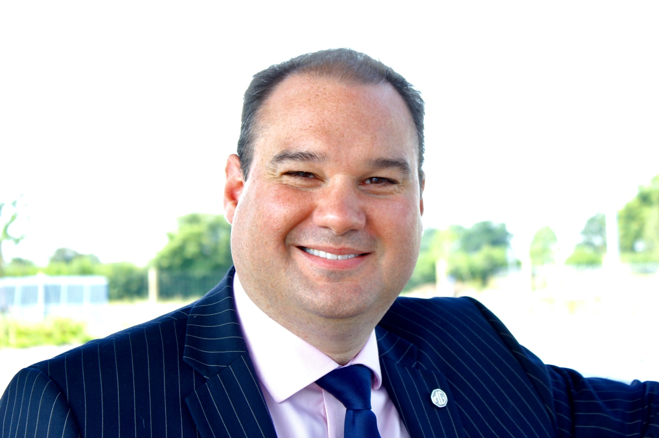

- MG Motor appoints new Head of Sales
- Andrew Stuart to lead brand’s sales strategy as rapid growth continues
- Extensive motor industry CV with Hyundai, Nissan and VW Group
- MG sales increased by 76% year-on-year
- All MGs covered by brand’s famous 7 year warranty

MG MOTOR has appointed Andrew Stuart as its new Head of Sales.
His recruitment comes as MG continues its rapid expansion, with a year-on-year sales increase of 76% and a quickly growing dealer network, with over 130 sites already in the UK and more to come by year end.
Andrew has an impressive and established automotive industry CV, having previously worked in sales and planning roles for Hyundai, Nissan and VW Group. He will be responsible for sales performance, customer experience across retail and fleet channels and used cars, including MG’s EV models.
He said: “It’s a really exciting time to be joining MG Motor, with an engaged network and huge growth opportunities, not to mention our leadership in affordable EVs. The MG brand has great product and huge potential. I’m really looking forward to working with all our dealer partners to continue on the path of sustainable, profitable growth.”
MG Motor Commercial Director, Guy Pigounakis, added: “We’re delighted to welcome Andrew into the MG Motor team – he has a terrific automotive background and is the perfect fit for driving up volumes as we continue to increase our market share, especially in the EV sector.”
MG currently offers six models in the UK including three plug-in cars – the established MG ZS EV, the game-changing All New MG5 EV and MG HS Plug-in Hybrid, all backed up by MG’s incredible 7 year warranty and fast-developing dealer network.
To find your local dealer, or to discover the high-tech, value-for-money range of cars on offer, please visit MG.CO.UK.
- ENDS –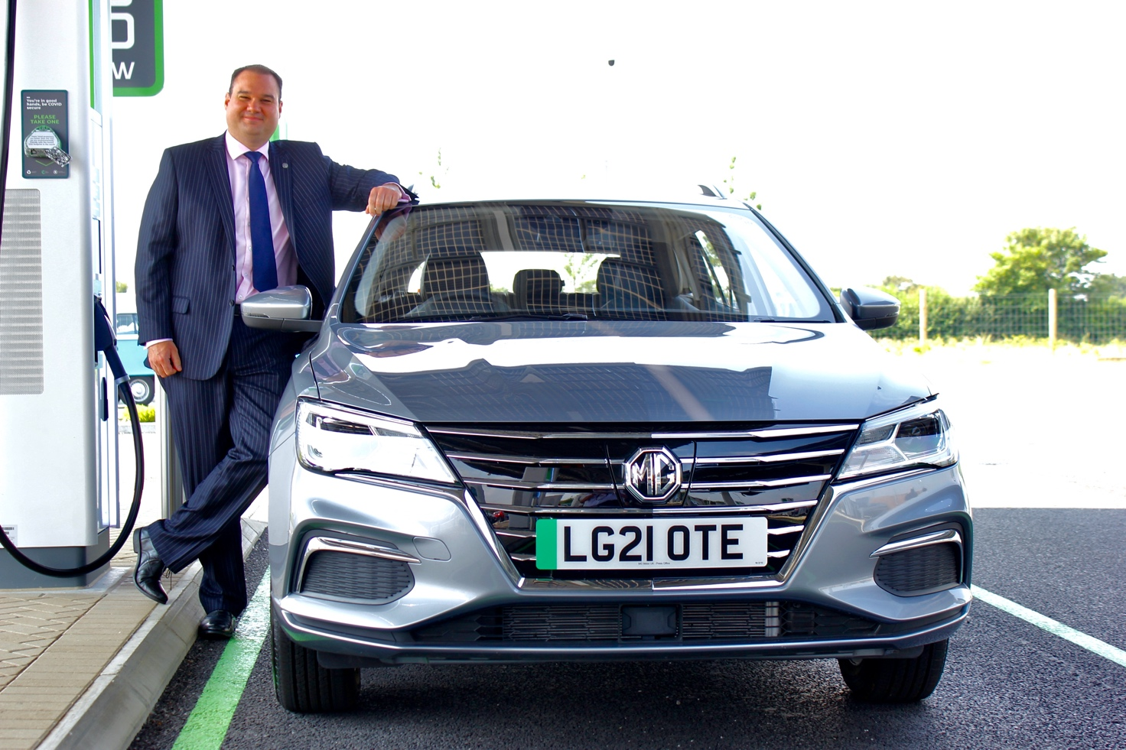
Notes to editors:

About MG

Tracing its history back to 1924, MG is the iconic British motoring brand, famous for building sporty, exciting and value-for-money cars which are always fun to drive. From the original MG 14/28 Super Sports car, designed by the legendary Cecil Kimber, to the all-electric MG5 EV of today, MG has always been innovative, always been radical and always been fun!

Today, MG is the fastest growing car brand in the UK, fielding a six-car range of practical and affordable hatchbacks, SWs and SUVs. Designed in Marylebone, London, and manufactured in state-of-the-art factories in several countries, today’s MGs are practical, spacious, packed with technology and perfect for modern life. With a national network of over 130 dealerships, MG is accessible to customers everywhere with professional sales and aftersales provision across the UK.

Backed by SAIC Motor, one of the world’s largest automotive companies, all new MGs are built with world-class components and are backed by a comprehensive manufacturer’s 7 year warranty. Well-established in the UK, MGs are now sold worldwide with western Europe being the latest region for expansion.

For further information please contact:
CRAIG CHEETHAM
MG Press Office
T: +44 7900 085571
E: craig@crccreative.co.uk
www.mg.co.uk

