PRESS INFORMATION – 11 JANUARY 2021

MG ZS EV CROWNED MEDIUM EV OF THE YEAR FOR SECOND YEAR IN SUCCESSION BY COMPANY CAR AND VAN

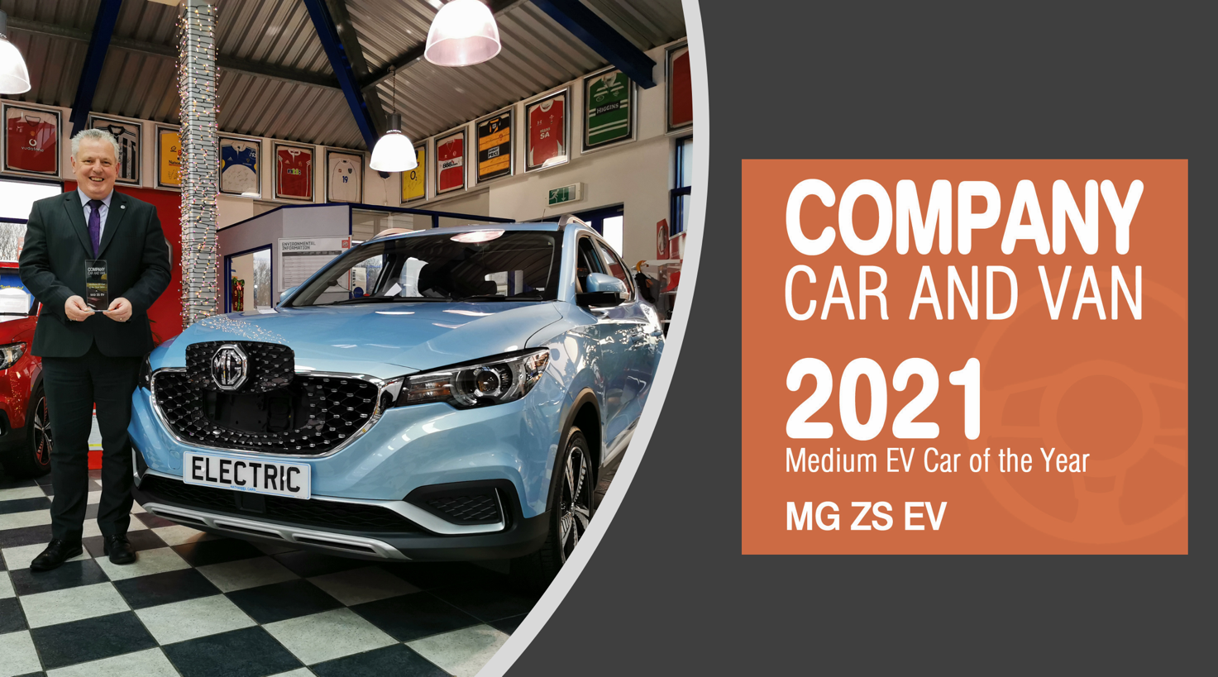

- MG ZS EV wins major fleet award for second year in a row
- Company Car and Van names ZS EV its Medium EV Car of the Year 2021
- ZS EV and MG5 EV are eligible for 0% Benefit-in-Kind tax for the 2021-22 tax year, making them even more appealing to business drivers
- All MG EVs covered by brand’s famous 7 year warranty
- 66.6% of latest shipment of MGs are EV or PHEV

MG’s ground-breaking electric ZS has won a major fleet accolade for the second year in a row.
The MG ZS EV was crowned Medium EV Car of the Year 2021 by Company Car and Van, having taken the same award from the title in 2020. The title is focused on small to medium enterprise firms with smaller fleets of less than 50 vehicles.
Company Car and Van Editor, Andrew Walker, said: “MG deservedly retains this award. Despite increased competition, the ZS EV still manages to offer a cracking level of specification, coupled to a 163-mile electric range, with plenty of room on board for a family of five, all at an incredible price. Amazing!”
MG Motor’s National Fleet Sales Manager, Geraint Isaac, added: “MG’s increasingly diverse EV model range has given us a massive fleet opportunity that we’re taking every opportunity to grow, with SMEs and user choosers an important part of our growth strategy. To win this award for the second year running goes to show how attractive ZS EV is to smaller fleets and company car users and it’s a massive honour to receive it once again.”
The news comes on the back of All New MG5 EV winning its first major award after WhichEV named it as its Best Value EV, thanks to its 214 mile range, extensive equipment, affordable purchase price and lengthy warranty.
In addition, the MG ZS EV was also Highly Commended in the same category of the first high profile EV awards ceremony in 2021.
Both the ZS EV and MG5 EV are eligible for 0% Benefit-in-Kind tax for the 2021-22 tax year, making them even more appealing to business drivers.
The iconic brand – which has been a motor industry innovator for almost a century – is already ahead of the curve with its plan to offer affordable EVs for everyone, reflected by the fact that the recent largest single shipment of MGs contained a 66% EV mix, made up of the company’s best-selling MG ZS EV, All New MG5 EV and MG HS Plug-in.
MG will be engaging with its 120-strong (and growing) dealer network over the coming months to offer reassurance to customers and help them make the most informed EV choice possible.
It currently offers three plug-in models in the UK – the established MG ZS EV, the game-changing All New MG5 EV and MG HS Plug-in, all backed up by MG’s incredible 7 year warranty and fast-developing dealer network.
To find your local dealer, or to discover the high-tech, value-for-money range of cars on offer, please visit MG.CO.UK, or to find out more about MG Fleet, contact a member of the Fleet Team at fleet@mg.co.uk

- ENDS -
Notes to editors:

About MG

Tracing its history back to 1924, MG is the iconic British motoring brand, famous for building sporty, exciting and value-for-money cars which are always fun to drive. From the original MG 14/28 Super Sports car, designed by the legendary Cecil Kimber, to the all-electric MG5 EV of today, MG has always been innovative, always been radical and always been fun!

Today, MG is the fastest growing car brand in the UK, fielding a six-car range of practical and affordable hatchbacks, SWs and SUVs. Designed in Marylebone, London, and manufactured in state-of-the-art factories in several countries, today’s MGs are practical, spacious, packed with technology and perfect for modern life. With a national network of 120 dealerships, MG is accessible to customers everywhere with professional sales and aftersales provision across the UK.

Backed by SAIC Motor, one of the world’s largest automotive companies, all new MGs are built with world-class components and are backed by a comprehensive manufacturer’s 7 year warranty. Well-established in the UK, MGs are now sold worldwide with western Europe being the latest region for expansion during 2020.

For further information please contact:
CRAIG CHEETHAM
MG Press Office
T: +44 7900 085571
E: craig@crccreative.co.uk
www.mg.co.uk

