PRESS INFORMATION – 9 AUGUST 2021

MG MOTOR AND BRISTOL STREET OPEN NEW CARLISLE SHOWROOM

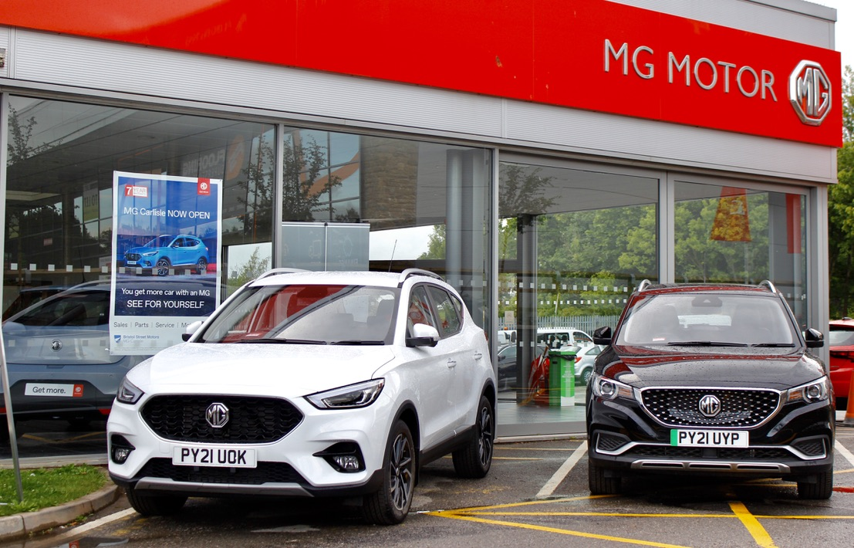

- MG Motor and Bristol Street open new showroom in Carlisle
- First Bristol Street site to retail MG
- Move follows over 30 new dealers joining the brand in past 12 months
- EV leadership and great value proposition make MG a highly desirable franchise
- MG sales increased by 76% year-on-year
- All MGs covered by brand’s famous 7 year warranty

ONE OF the UK’s best known dealer groups – Bristol Street – is opening its first MG franchise in Carlisle.
The company – part of Vertu Motors PLC – is adding MG to its portfolio in the north-west as it believes the brand offers a great opportunity to increase sales and EV penetration.
Bristol Street MG will be on the city’s Kingstown Industrial Estate and will carry a range of new and used cars as well as offering on-site EV charging, servicing and aftersales.
The site will offer the full range of MG vehicles and will also provide specialist advice to Motability customers. MG becomes the 33rd manufacturer represented by Vertu Motors plc – the most of any dealer group in the UK.
Robert Forrester, chief executive of Bristol Street Motors, said: “I am delighted to announce the introduction of MG to our portfolio of manufacturers.
“MG is an iconic British motoring brand, famous for building sporty, exciting, and value-for-money cars which are always fun to drive. It is the fastest growing car brand in the UK and it’s really exciting to open our first site in Carlisle.
“It will be our third franchise in the city, demonstrating our commitment to the North West and cementing our place as the dealer group representing the most brands.”
MG Motor Commercial Director, Guy Pigounakis, added: “We are delighted to welcome Bristol Street into the MG family and the Carlisle location represents a great opportunity for us in the North West.
“Working with a group as high profile as this shows just how far and how quickly MG has grown in recent years and, with our rapidly growing EV portfolio in particular, we look forward to a long-lasting a fruitful relationship with the dealer group.”
MG currently offers six models in the UK including three plug-in cars – the established MG ZS EV, the game-changing All New MG5 EV and MG HS Plug-in Hybrid, all backed up by MG’s incredible 7 year warranty and fast-developing dealer network.
To find your local dealer, or to discover the high-tech, value-for-money range of cars on offer, please visit MG.CO.UK.
- ENDS –
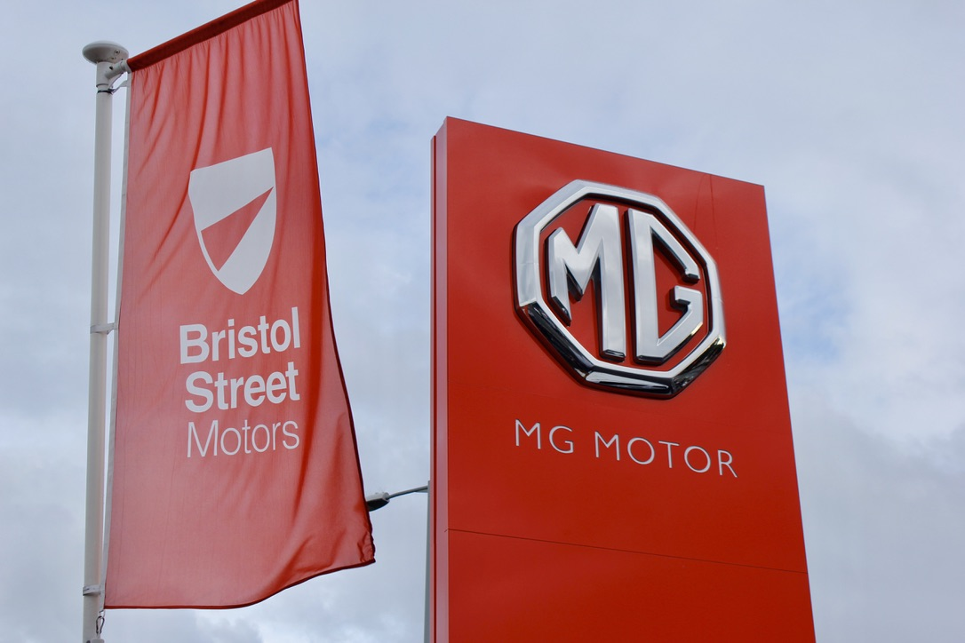
Notes to editors:

About MG

Tracing its history back to 1924, MG is the iconic British motoring brand, famous for building sporty, exciting and value-for-money cars which are always fun to drive. From the original MG 14/28 Super Sports car, designed by the legendary Cecil Kimber, to the all-electric MG5 EV of today, MG has always been innovative, always been radical and always been fun!

Today, MG is the fastest growing car brand in the UK, fielding a six-car range of practical and affordable hatchbacks, SWs and SUVs. Designed in Marylebone, London, and manufactured in state-of-the-art factories in several countries, today’s MGs are practical, spacious, packed with technology and perfect for modern life. With a national network of over 130 dealerships, MG is accessible to customers everywhere with professional sales and aftersales provision across the UK.

Backed by SAIC Motor, one of the world’s largest automotive companies, all new MGs are built with world-class components and are backed by a comprehensive manufacturer’s 7 year warranty. Well-established in the UK, MGs are now sold worldwide with western Europe being the latest region for expansion.

For further information please contact:

LINDA ROBINSON
PR and Experiential Manager, MG Motor
T: +44 203 917 5834
E: linda.robinson@mg.co.uk

CRAIG CHEETHAM
MG Press Office
T: +44 7900 085571
E: craig@crccreative.co.uk

www.mg.co.uk

