PRESS INFORMATION – 01 JUNE 2021

MG OFFERS £750 INCENTIVE FOR ELECTRIC CAR NEWCOMERS
WHO TEST DRIVE A NEW MG EV IN JUNE

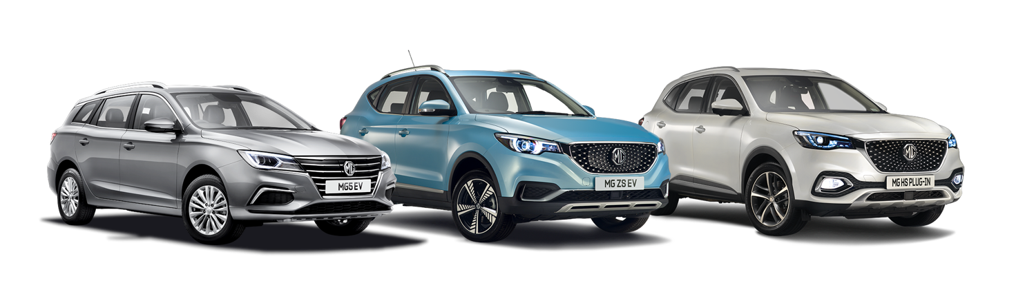

- Test drive a new electric MG in June and get £750 off
- Month-long test drive event allows no-obligation road tests for potential EV converts
- Simply book a test drive and download the voucher
- Almost a third of new MGs sold so far in 2021 are pure electric
- All new MGs come with 7-Year Warranty

Anybody who is sitting on the electric fence when it comes to choosing their next car can get some help in embracing the change thanks to MG Motor’s Electric for Everyone commitment.
From June 1 to 30, the UK’s affordable EV pioneer is offering an incredible £750 discount across its entire EV portfolio.
Until June 30, 2021, anyone booking a test drive in the company’s MG ZS EV, MG5 EV or MG HS Plug-in Hybrid can download a £750 discount voucher, which can be used as money off the already outstanding value range of EVs if they place an order before the closing date. The £750 bonus is in addition to any other offer at the time of purchase and is compatible with 0% finance deals.
MG’s Commercial Director, Guy Pigounakis, said: “MG’s mission is to make EV motoring accessible for everyone as we head towards 2030. Customer acceptance and demand for EVs has grown as battery range has gone up and cost has come down, and we are proud that MG has become the go-to brand for affordable electric cars.
“Our recent sales results show that MG’s commitment to making EVs affordable for everyone is resonating with the car-buying public and to help make EVs as affordable as possible for everyone, anyone who takes a test drive in one of our electric or plug-in models in June will get a further incentive in the form of a £750 thank you.”
The money off voucher is a further plus for anyone considering a plug-in MG, especially as the MG ZS EV and MG5 EV are both still eligible for the government’s £2,500 zero emissions car grant, which was changed in March so more expensive EVs no longer qualified.
MG has seen over 30% of its sales so far in 2021 through battery electric vehicles (BEVs), taking a 5.5% share of the entire BEV market in the UK. The brand also achieved its best ever sales month in March 2021, with 3,956 registrations and a record overall market share of 1.45%, a 28.1% growth over March 2020.
MG currently offers three plug-in models in the UK – the established MG ZS EV, the game-changing All New MG5 EV and MG HS Plug-in Hybrid, all backed up by MG’s incredible 7 year warranty and fast-developing dealer network.
To find your local dealer, or to discover the high-tech, value-for-money range of cars on offer, please visit MG.CO.UK, or to download the voucher go to https://mg.co.uk/voucher/
- ENDS –

Notes to editors:

About MG

Tracing its history back to 1924, MG is the iconic British motoring brand, famous for building sporty, exciting and value-for-money cars which are always fun to drive. From the original MG 14/28 Super Sports car, designed by the legendary Cecil Kimber, to the all-electric MG5 EV of today, MG has always been innovative, always been radical and always been fun!

Today, MG is the fastest growing car brand in the UK, fielding a six-car range of practical and affordable hatchbacks, SWs and SUVs. Designed in Marylebone, London, and manufactured in state-of-the-art factories in several countries, today’s MGs are practical, spacious, packed with technology and perfect for modern life. With a national network of over 120 dealerships, MG is accessible to customers everywhere with professional sales and aftersales provision across the UK.

Backed by SAIC Motor, one of the world’s largest automotive companies, all new MGs are built with world-class components and are backed by a comprehensive manufacturer’s 7 year warranty. Well-established in the UK, MGs are now sold worldwide with western Europe being the latest region for expansion during 2021.

For further information please contact:
CRAIG CHEETHAM
MG Press Office
T: +44 7900 085571
E: craig@crccreative.co.uk
www.mg.co.uk

