PRESS INFORMATION – XX MAY 2021

PERRYS OPENS NEW MG MOTOR SITE IN AYLESBURY

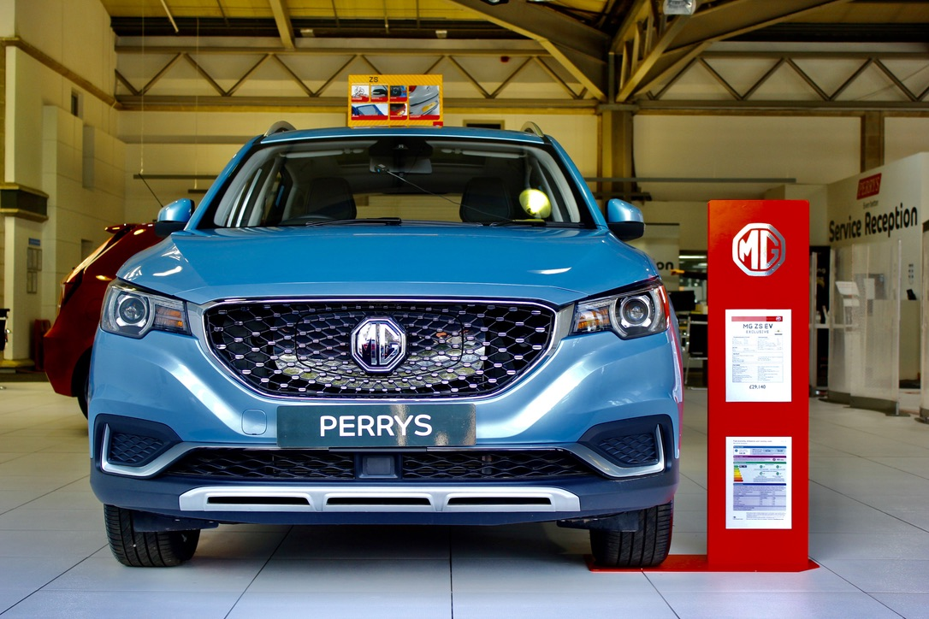

- MG Motor and Perrys open new showroom in Aylesbury
- Network of 130 dealers planned by end of 2021
- Move follows 28 new dealers joining the brand in past 12 months
- EV leadership and great value proposition make MG a highly desirable franchise
- MG sales increased by 41% in 2020
- All MGs covered by brand’s famous 7 year warranty

A NEW name for MG is now operating in Aylesbury, with independent dealer group Perrys opening an MG franchise in the busy Buckinghamshire town.
The new dealership is situated on the town’s busy Bicester Road and has an indoor showroom offering sales, aftersales and used car facilities, as well as EV charging facilities and a wide range of customer choice.
It sits alongside Perrys’ other sites in Aylesbury - the county town of Buckinghamshire - in the heart of the busy Home Counties.
Denise Millard, Executive Director for Perrys Motor Sales , said: “MG is a brand that’s really capturing the imagination, with great value cars that are good quality, well-equipped and backed by the assurance of a brilliant seven-year warranty.
“The brand is also one of the fastest-growing electric car brands in the UK and is a perfect fit for our portfolio.”
MG Motor is gearing up to increase its network to 130 dealers by the end of 2021, among which are Perrys existing sites for the brand in Preston and Huddersfield. With a range now encompassing six models and a rapidly growing reputation for offering affordable EVs for everyone, MG has seen 28 new sites join its network in the past 12 months.
MG Motor’s Commercial Director, Guy Pigounakis, said: “As the UK’s fastest-developing car brand, the appointment of Perrys in Aylesbury will really help us grow our presence in the Home Counties, via a trusted independent dealer group that is already well-established in the region. It’s further proof that MG is a highly desirable franchise thanks to great value cars that are great to drive, packed with technology and backed by a 7-year warranty.”
MG currently offers six models in the UK including three plug-in cars – the established MG ZS EV, the game-changing All New MG5 EV and MG HS Plug-in Hybrid, all backed up by MG’s incredible 7 year warranty and fast-developing dealer network.
To find your local dealer, or to discover the high-tech, value-for-money range of cars on offer, please visit MG.CO.UK.
- ENDS –
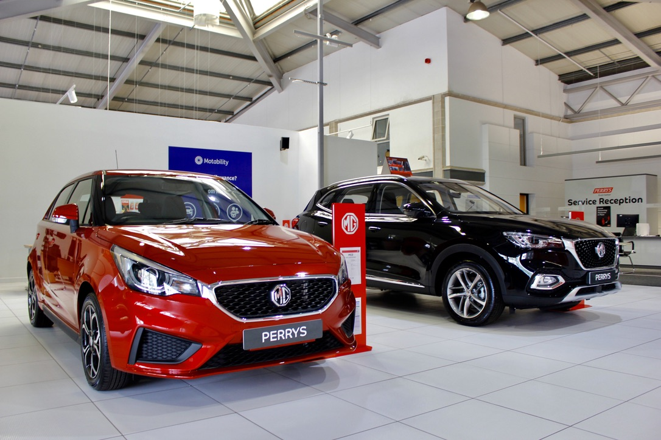

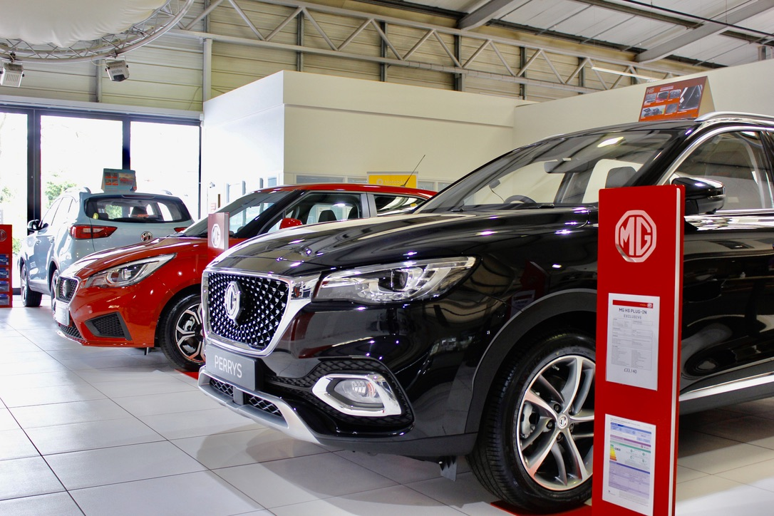
Notes to editors:

About MG

Tracing its history back to 1924, MG is the iconic British motoring brand, famous for building sporty, exciting and value-for-money cars which are always fun to drive. From the original MG 14/28 Super Sports car, designed by the legendary Cecil Kimber, to the all-electric MG5 EV of today, MG has always been innovative, always been radical and always been fun!

Today, MG is the fastest growing car brand in the UK, fielding a six-car range of practical and affordable hatchbacks, SWs and SUVs. Designed in Marylebone, London, and manufactured in state-of-the-art factories in several countries, today’s MGs are practical, spacious, packed with technology and perfect for modern life. With a national network of over 120 dealerships, MG is accessible to customers everywhere with professional sales and aftersales provision across the UK.

Backed by SAIC Motor, one of the world’s largest automotive companies, all new MGs are built with world-class components and are backed by a comprehensive manufacturer’s 7 year warranty. Well-established in the UK, MGs are now sold worldwide with western Europe being the latest region for expansion.

About Perrys

Perrys Motor Sales is a franchised car dealer, with its head office in Northampton, operating fifty showrooms at 25 sites across the UK now including three MG dealerships.

For further information please contact:
CRAIG CHEETHAM
MG Press Office
T: +44 7900 085571
E: craig@crccreative.co.uk
www.mg.co.uk

