PRESS INFORMATION – 28 JULY 2021

MG ZS EV SCOOPS TOP WHAT CAR? AWARD

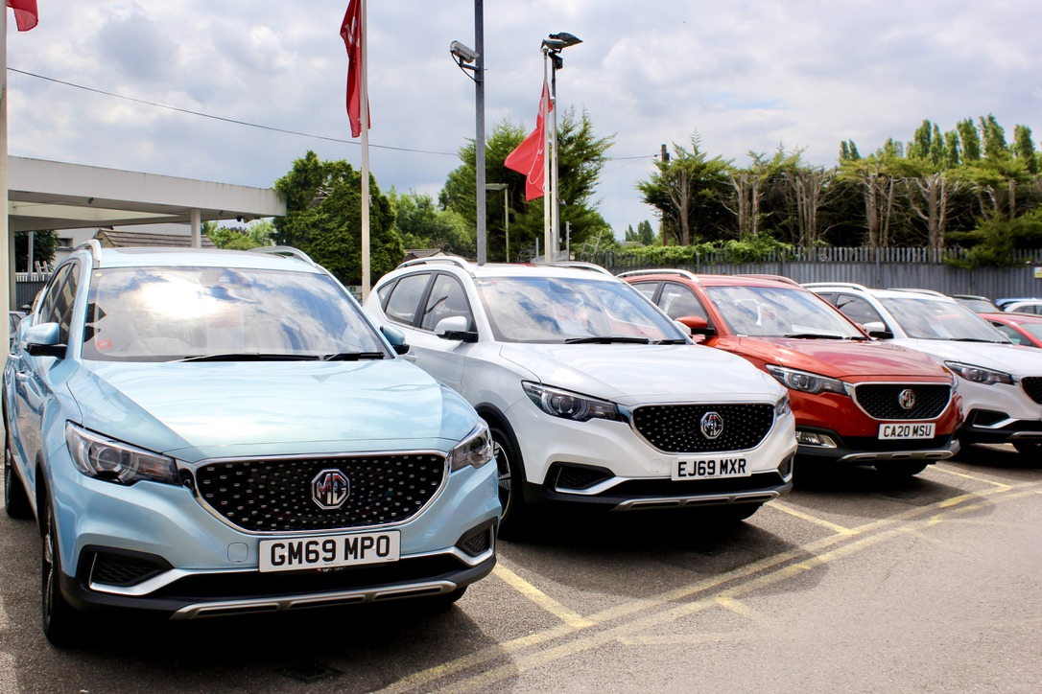

- MG ZS EV voted best used electric small SUV by consumer champion
- ZS EV offers unbeatable value as a used car according to What Car?
- Rapidly developing network sees increased used car stock
- All MGs covered by brand’s famous (and fully transferable) 7 year warranty

LEADING consumer car expert What Car? has named the MG ZS EV as its best used electric small SUV in its Electric Car Awards.
The magazine and website, renowned for its no-nonsense consumer advice, awarded the accolade to the ZS EV for its “nigh on impossible to beat” value for money.
What Car? Editor, Steve Huntingford, said: “Many electric SUVs carry premium price tags both new and used, but not the MG ZS EV. This car is really in a class of its own, offering buyers a well-equipped, emissions-free small SUV for tempting second-hand prices.”
The judges also praised the ZS EV’s impressive standard equipment, performance and interior design.
Accepting the award, MG’s Marketing Director David Pugh said: “With its transferable 7 Year Warranty, low running costs and incomparable value for money, the ZS EV makes every bit as much sense used as it does new.
“At MG we have pioneered the introduction of practical and affordable EVs to the UK market, so it’s almost inevitable that these ground breaking new EVs become equally significant used car pioneers. If EVs are to become mainstream in the UK then they need to be just as integral to the used car market as they are to new cars, and we’re proud that our early products are leading this important transition.
“We’re delighted to have received this recognition from What Car? at a time when our dealer network is growing rapidly and used car supply is starting to develop, as it represents yet another chapter in MG’s quest to offer affordable EV motoring for everyone.”
MG currently offers six models in the UK including three plug-in cars – the established MG ZS EV, the game-changing MG5 EV Long Range and MG HS Plug-in Hybrid, all backed up by MG’s incredible 7 Year Warranty and fast-developing dealer network.
To find your local dealer, or to discover the high-tech, value-for-money range of cars on offer, please visit MG.CO.UK.
- ENDS –
Notes to editors:

About MG

Tracing its history back to 1924, MG is the iconic British motoring brand, famous for building sporty, exciting and value-for-money cars which are always fun to drive. From the original MG 14/28 Super Sports car, designed by the legendary Cecil Kimber, to the all-electric MG5 EV of today, MG has always been innovative, always been radical and always been fun!

Today, MG is the fastest growing car brand in the UK, fielding a six-car range of practical and affordable hatchbacks, SWs and SUVs. Designed in Marylebone, London, and manufactured in state-of-the-art factories in several countries, today’s MGs are practical, spacious, packed with technology and perfect for modern life. With a national network of over 130 dealerships, MG is accessible to customers everywhere with professional sales and aftersales provision across the UK.

Backed by SAIC Motor, one of the world’s largest automotive companies, all new MGs are built with world-class components and are backed by a comprehensive manufacturer’s 7 year warranty. Well-established in the UK, MGs are now sold worldwide with western Europe being the latest region for expansion.

For further information please contact:
CRAIG CHEETHAM
MG Press Office
T: +44 7900 085571
E: craig@crccreative.co.uk
www.mg.co.uk

