PRESS INFORMATION – FOR IMMEDIATE RELEASE
XX AUGUST 2021

MG MOTOR CONTINUES RAPID GROWTH AND AFFORDABLE EV LEADERSHIP WITH BIGGEST SHIPMENT EVER TO ARRIVE IN THE UK

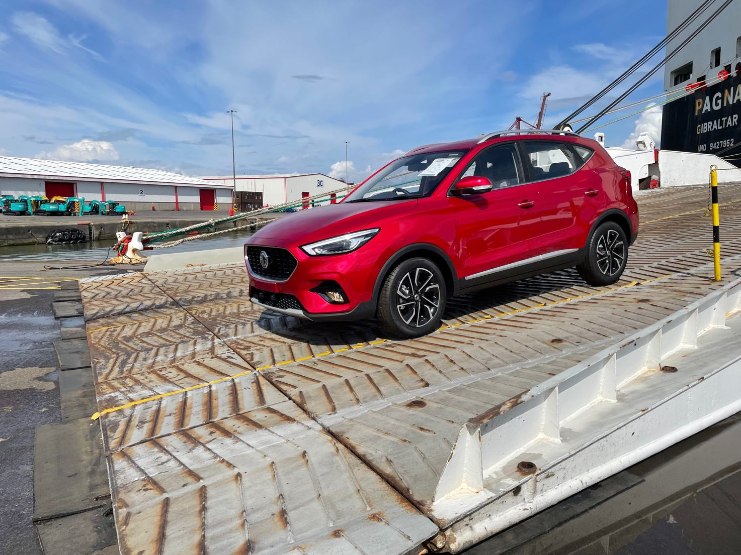

- Largest ever shipment of MGs arrives at Portbury Docks
- 2,892 new MGs arrive by boat in the UK
- Over a quarter of new arrivals are MG5 EV Long Range
- MG sales increased by 67% year-on-year
- All MGs covered by brand’s comprehensive 7 year warranty

MG Motor has seen its biggest ever shipment of new cars arrive in the UK at Bristol’s Portbury Docks, eclipsing the shipment of 2,000 vehicles which arrived in October 2020
A total of 2,892 new MGs arrived at the port this week as the rapidly growing brand gears up for a busy September, with the new car market preparing for the new ‘71’- registration plate.
Over a quarter of the cars contained in the shipment (26.2%) were the new long range MG5 EV Long Range, which made its debut last month, underlining its increasing popularity.
MG Motor Commercial Director, Guy Pigounakis, said: “This is the biggest single shipment of MGs to arrive in the UK and positions us strongly for September, There have been stock challenges across the car industry in recent months due to a number of external forces, so it’s reassuring for both our customers and our dealer network to know that MG is in a strong position, with a wide mix of vehicles available to meet market demand.”
MG currently offers six models in the UK including three plug-in cars – the established MG ZS EV, the game-changing All New MG5 EV and MG HS Plug-in Hybrid, all backed up by MG’s comprehensive manufacturer’s 7 year warranty and fast-developing dealer network.
To find your local dealer, or to discover the high-tech, value-for-money range of cars on offer, please visit MG.CO.UK.
- ENDS –
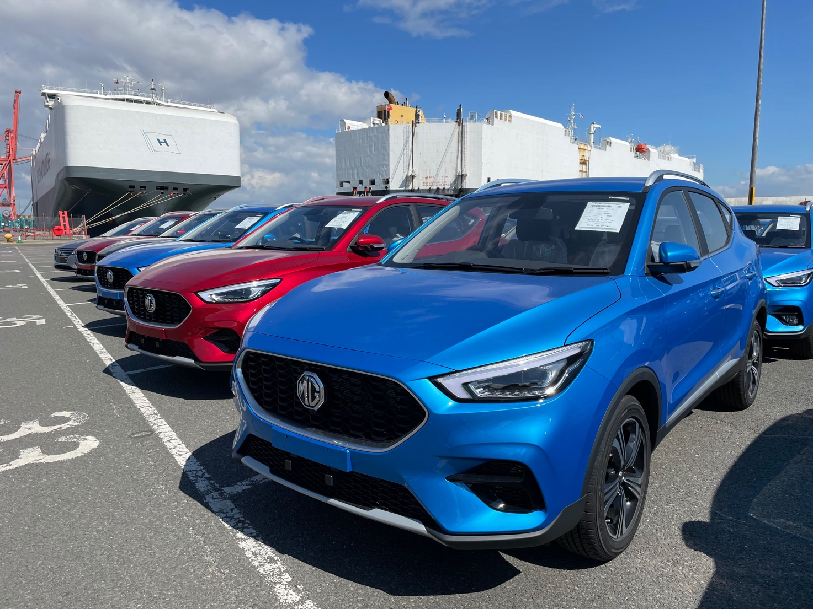
Notes to editors:

About MG

Tracing its history back to 1924, MG is the iconic British motoring brand, famous for building sporty, exciting and value-for-money cars which are always fun to drive. From the original MG 14/28 Super Sports car, designed by the legendary Cecil Kimber, to the all-electric MG5 EV of today, MG has always been innovative, always been radical and always been fun!

Today, MG is the fastest growing car brand in the UK, fielding a six-car range of practical and affordable hatchbacks, SWs and SUVs. Designed in Marylebone, London, and manufactured in state-of-the-art factories in several countries, today’s MGs are practical, spacious, packed with technology and perfect for modern life. With a national network of over 130 dealerships, MG is accessible to customers everywhere with professional sales and aftersales provision across the UK.

Backed by SAIC Motor, one of the world’s largest automotive companies, all new MGs are built with world-class components and are backed by a comprehensive manufacturer’s 7 year warranty. Well-established in the UK, MGs are now sold worldwide with western Europe being the latest region for expansion.

For further information please contact:

LINDA ROBINSON
PR and Experiential Manager, MG Motor
T: +44 0203 917 5834
E: linda.robinson@mg.co.uk

CRAIG CHEETHAM
MG Press Office
T: +44 07900 085571
E: craig@crccreative.co.uk

www.mg.co.uk

