PRESS INFORMATION – 4 MAY 2021

MG INDULGES IN A BIT OF ‘GIVE AND TAKE’ TO HELP
CAR BUYERS MAKE THE CHANGE TO EV

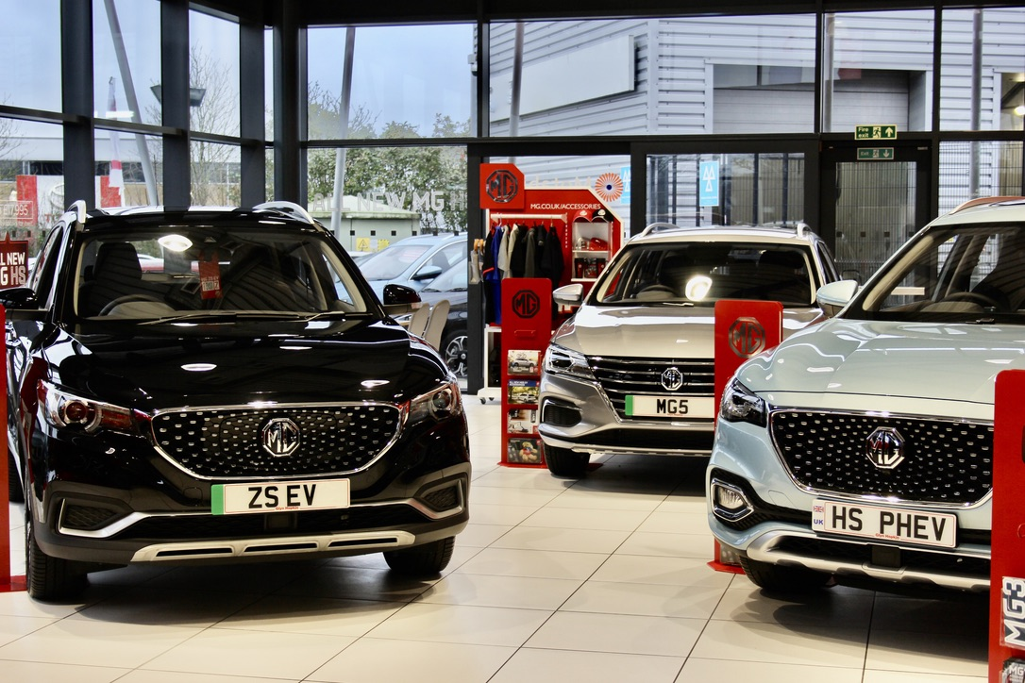

- New MG ‘Give and Take’ campaign gives extra help to buyers trading in ICE cars
- Additional £750 discount on new electric and plug-in hybrid cars, on top of any other deal
- Applies to MG ZS EV, MG5 EV and MG HS Plug-in Hybrid
- All covered by MG’s incredible 7 Year Warranty

Customers trading in a petrol or diesel car will be given an extra £750 towards their new electric purchase in May via participating MG dealerships.
The £750 contribution towards any new MG ZS EV, MG5 EV or MG HS Plug-in Hybrid applies to retail buyers who are making the switch from petrol or diesel to plug-in motoring and is in addition to any other retail or finance offer, as well as the part-exchange price offered by the dealer.
Simply place an order for a new electrified MG for delivery this month and the extra £750 discount will be applied to the deal.
MG’s Commercial Director, Guy Pigounakis, said: “In order to make the switch to electric as simple as possible for those considering a plug-in car as their next purchase, MG is committed to giving customers an extra £750 incentive while taking away their old petrol or diesel car without any detriment to its trade-in value.
“We want as many customers as possible to join the electric revolution by making EV and plug-in hybrid models as affordable as possible, offering excellent specifications, terrific value, great driver appeal and an impressive battery-powered range across the line-up.”
MG currently offers three plug-in models in the UK – the established MG ZS EV, the game-changing All New MG5 EV and MG HS Plug-in Hybrid, all backed up by MG’s incredible 7 year warranty and fast-developing dealer network.
To find your local dealer, or to discover the high-tech, value-for-money range of cars on offer, please visit MG.CO.UK.
- ENDS –
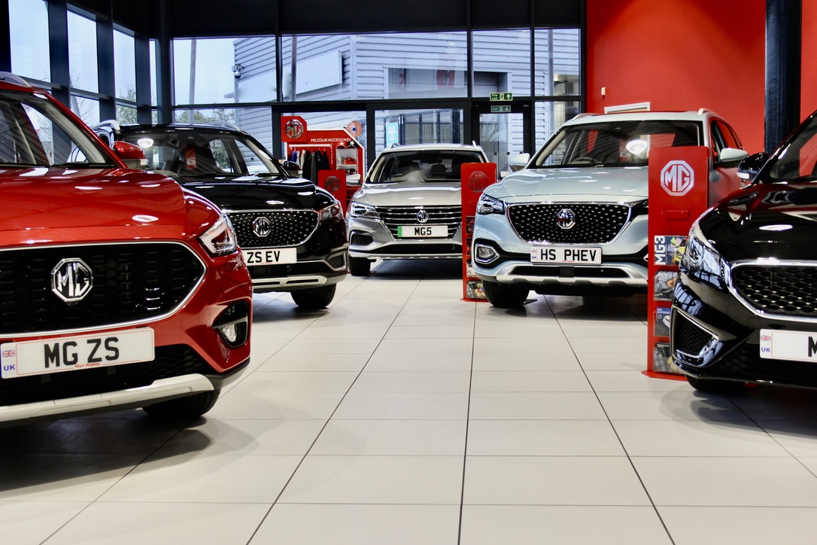
Notes to editors:

About MG

Tracing its history back to 1924, MG is the iconic British motoring brand, famous for building sporty, exciting and value-for-money cars which are always fun to drive. From the original MG 14/28 Super Sports car, designed by the legendary Cecil Kimber, to the all-electric MG5 EV of today, MG has always been innovative, always been radical and always been fun!

Today, MG is the fastest growing car brand in the UK, fielding a six-car range of practical and affordable hatchbacks, SWs and SUVs. Designed in Marylebone, London, and manufactured in state-of-the-art factories in several countries, today’s MGs are practical, spacious, packed with technology and perfect for modern life. With a national network of over 120 dealerships, MG is accessible to customers everywhere with professional sales and aftersales provision across the UK.

Backed by SAIC Motor, one of the world’s largest automotive companies, all new MGs are built with world-class components and are backed by a comprehensive manufacturer’s 7 year warranty. Well-established in the UK, MGs are now sold worldwide with western Europe being the latest region for expansion during 2021.

For further information please contact:
CRAIG CHEETHAM
MG Press Office
T: +44 7900 085571
E: craig@crccreative.co.uk
www.mg.co.uk

