PRESS INFORMATION – 18 MARCH 2021

MG TO EXTEND HIGHER LEVEL PLUG-IN GRANT UNTIL END OF MARCH

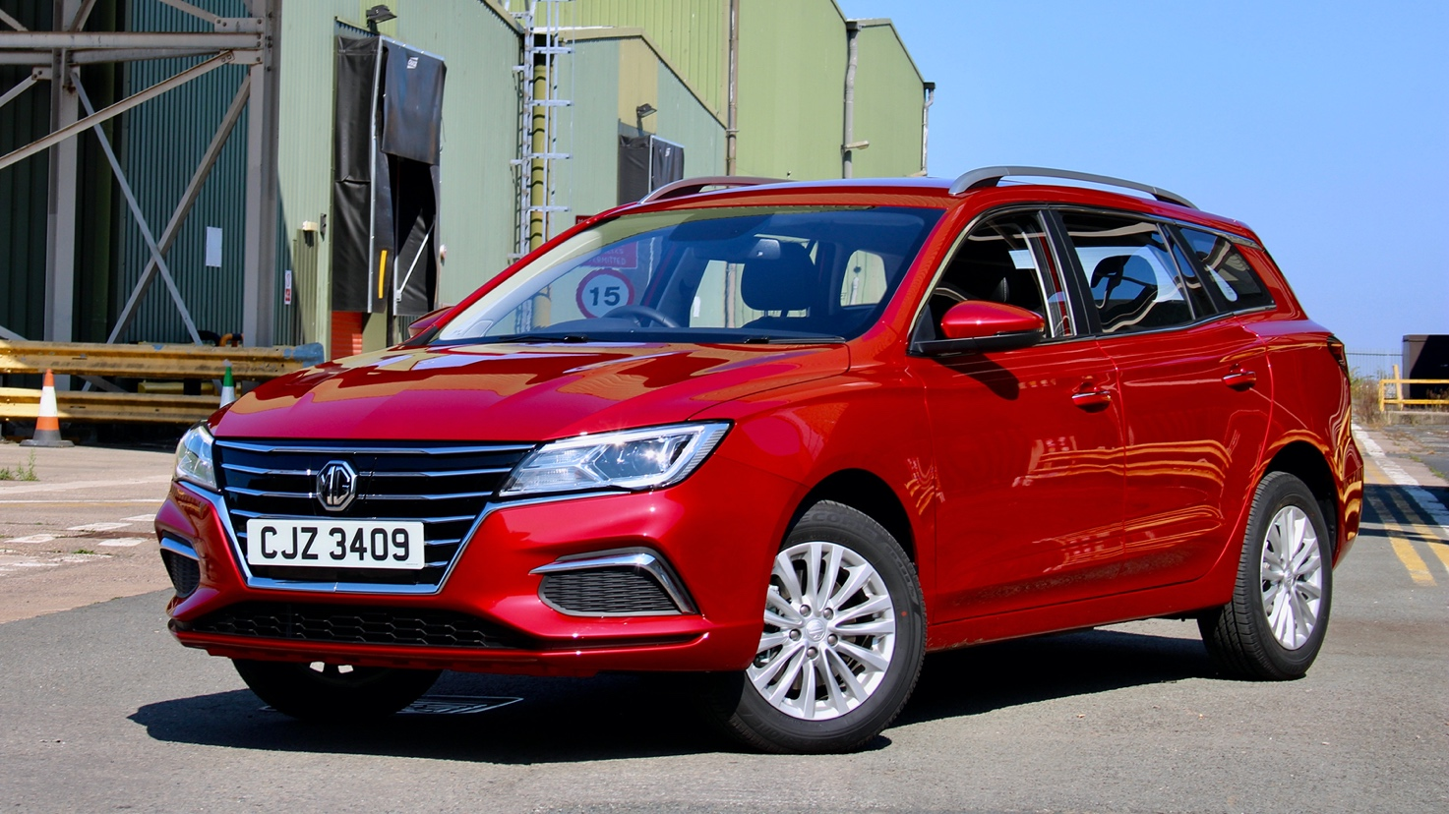

- MG commits to keeping £3k plug-in car grant until March 31, 2021
- Move comes after the Office for Zero Emissions Vehicles cuts back grant support with immediate effect
- New plug-in grant only applicable to affordable electric cars under £35,000
- All MG electric cars come in under the £35k threshold
- Includes MG5 EV and MG ZS Electric, both covered by brand’s famous 7 year warranty

The UK’s fastest-developing seller of electric cars has committed to honouring the £3,000 Plug-In Car Grant after the Office for Zero Emissions Vehicles (OZEV) cut the level of support and price cap for which awards are eligible on March 18th.
Both the MG ZS Electric and the new MG5 EV are covered by the PICG and will continue to be so despite the government cutting the price cap for grant-funded support from £50,000 to £35,000 in a move that it says will encourage the uptake of affordable vehicles.
At the same time, the £3,000 grant towards a new EV has been cut to £2,500, but thanks to its commitment to making EVs affordable for everyone, MG has committed to topping up the support level to its previous level for all customers who order a new MG EV in March 2021.
Guy Pigounakis, MG’s Commercial Director, said: “While we welcome any news that encourages people to buy affordable electric cars, for it to come in the middle of the toughest March trading conditions ever is a blow to customers.
“At MG, we believe in ensuring our customers are as happy as they can be with their new cars and in recognition that many of them will have made the decision to buy an MG EV with the £3,000 grant funding in mind, we have decided to honour that for all purchasers who order a new MG ZS Electric or MG5 EV for delivery before the end of this month.”
MG currently offers three plug-in models in the UK – the established MG ZS EV, the game-changing All New MG5 EV and MG HS Plug-in*, all backed up by MG’s incredible 7 year warranty and fast-developing dealer network.
To find your local dealer, or to discover the high-tech, value-for-money range of cars on offer, please visit MG.CO.UK.
- ENDS –
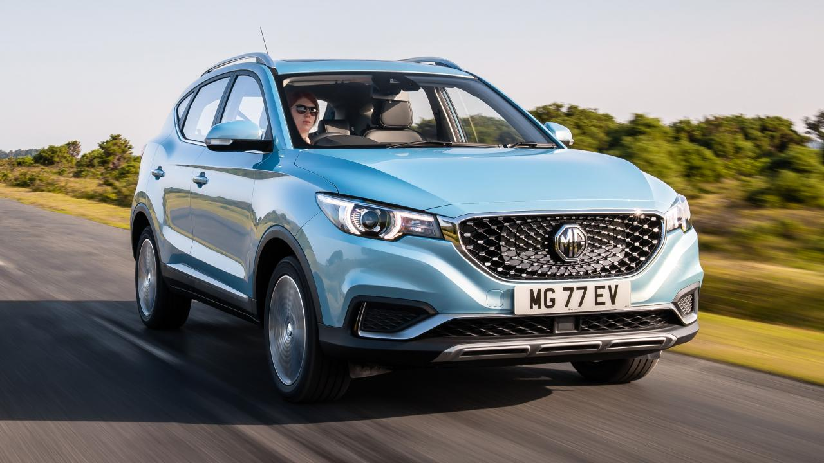
Notes to editors:

About MG

Tracing its history back to 1924, MG is the iconic British motoring brand, famous for building sporty, exciting and value-for-money cars which are always fun to drive. From the original MG 14/28 Super Sports car, designed by the legendary Cecil Kimber, to the all-electric MG5 EV of today, MG has always been innovative, always been radical and always been fun!

Today, MG is the fastest growing car brand in the UK, fielding a six-car range of practical and affordable hatchbacks, SWs and SUVs. Designed in Marylebone, London, and manufactured in state-of-the-art factories in several countries, today’s MGs are practical, spacious, packed with technology and perfect for modern life. With a national network of 120 dealerships, MG is accessible to customers everywhere with professional sales and aftersales provision across the UK.

Backed by SAIC Motor, one of the world’s largest automotive companies, all new MGs are built with world-class components and are backed by a comprehensive manufacturer’s 7 year warranty. Well-established in the UK, MGs are now sold worldwide with western Europe being the latest region for expansion during 2020.

*MG HS Plug-In is a hybrid and therefore not eligible for OZEV grant funding

For further information please contact:
CRAIG CHEETHAM
MG Press Office
T: +44 7900 085571
E: craig@crccreative.co.uk
www.mg.co.uk

