MG5 EV
UK media data

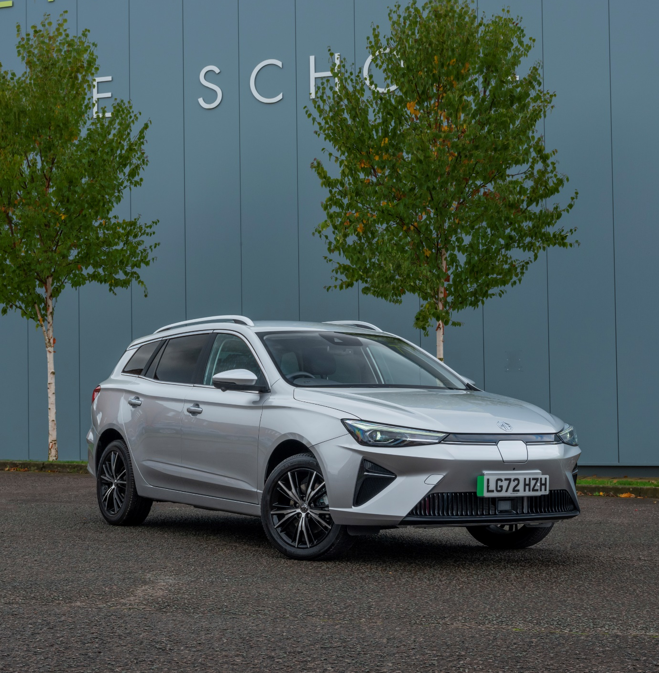

November 2022

Contents
3 - Introduction
4 - MG5 EV: At a glance
5 - Powertrain
6 - Design
7 - MG Pilot
8 - Interior and technology
9 - Model range specifications
10 - Market comparison
11 - Technical data
12 - Trim levels
14 - About MG

Introduction
The new MG5 EV is an adaptable, all-electric estate car that offers drivers a unique blend of style, space and practicality.
Starting from just £30,995, the second generation of MG’s multi-award-winning, fully electric estate car features a range of comprehensive upgrades to its exterior, interior and technology, while retaining highly competitive pricing.
The new MG5 builds on the success of the previous model, recently recognised as the UK’s 5th best-selling electric vehicle in 2022*.
Two specifications are available at launch - the MG5 EV SE and the MG5 EV Trophy. Both feature MG’s 61kWh Long Range battery as standard, capable of up to 250 miles (SE) or 235 miles (Trophy) on the WLTP cycle.
The 61kWh battery is also capable of recharging at up to 87kW, meaning a charge time of only 35 minutes from 10% - 80% using a 150kW DC rapid charger.
The MG5 EV carries MG’s trademark 7-year/80,000-mile warranty as standard, which remains one of the longest fully-transferable warranties in its class.
*SMMT data – September 2022.

MG5 EV: At a glance

- Price from £30,995 OTR
- Available in SE or Trophy specifications, with Long Range battery included as standard on both models
- Capable of up to 250 miles* range on the WLTP cycle
- Comprehensive upgrades to exterior design, including front and rear styling
- Interior design and technology also significantly updated
- Generous estate car practicality, with a maximum rear loading capacity of 1367 litres, adjustable dual-height boot floor and towing capacity up to 500kg
- A choice of 3 driving modes (Eco, Normal and Sport) optimises the MG5 EV for different driving conditions
- MG Pilot advanced driver assistance as standard on all models
- Two new major technology advancements over the previous model with the introduction of Vehicle-To-Load Technology (V2L) and MG’s iSMART app connectivity, both as standard across the range
- 7 year/80,000-mile fully transferable warranty as standard
*MG5 EV SE model.

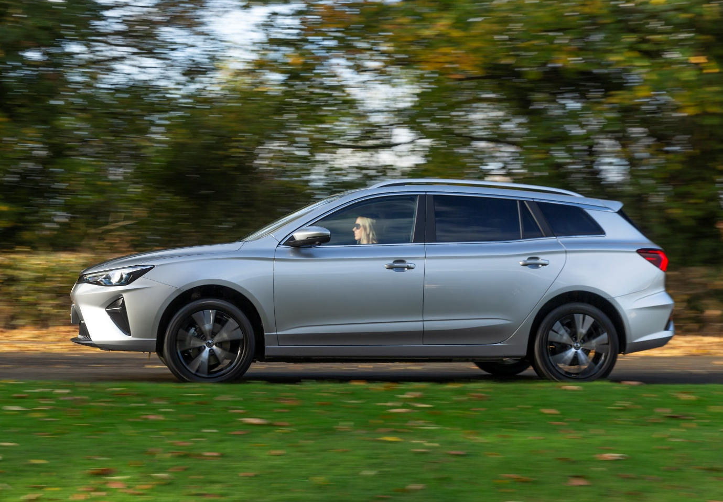

Powertrain
The MG5 EV offers a comfortable, effortless and responsive driving experience, with instant acceleration and refined ride quality.
- Long Range 61kWh battery as standard
- SE and Trophy models capable of up to 250 miles and 235 miles respectively on the WLTP cycle
- Powerful 115kW motor equivalent to 156PS
- 0-60mph in 7.3 seconds, with a top speed of 115mph
- 61kWh Long Range battery is capable of charging at up to 87kW, with a charge time of only 35 minutes from 10% - 80% (150kW DC rapid charger)

Design
The new MG5 EV offers significant styling updates, with a redesigned front and rear, along with technological improvements inside.
- Revised front and rear design language
- Enhanced LED headlights and taillights as standard
- New 16’’ (SE) and 17’’ (Trophy) alloy wheels
- Interior design and technology enhancements include a 10.25’’ widescreen infotainment system with upgraded software and 7” Driver Display
- Rear Privacy Glass available on Trophy Specification
- Six exterior colour options: Arctic White, Piccadilly Blue (Metallic), Black Pearl (Metallic), Hampstead Grey* (Metallic), Cosmic Silver* (Metallic) and Dynamic Red (Tri-Coat)
*New.
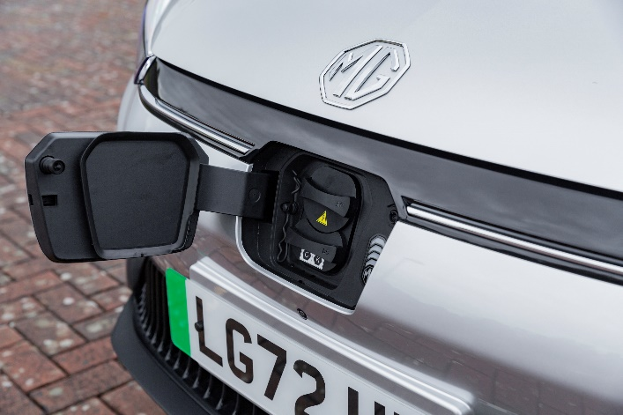
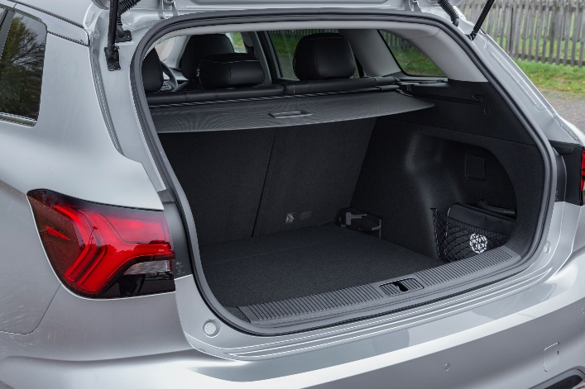
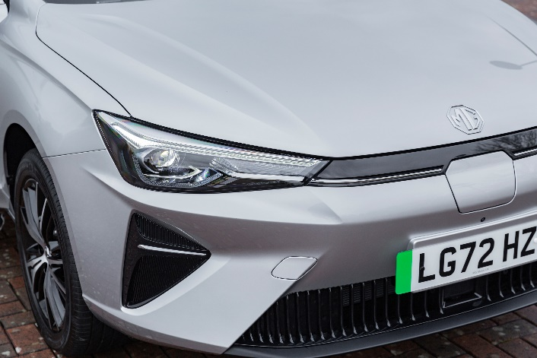
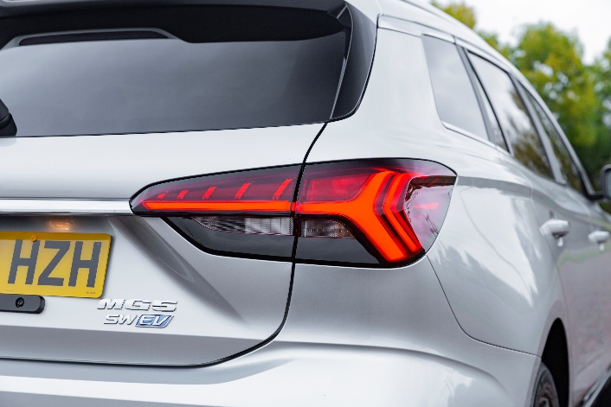

MG Pilot
MG Pilot is included as standard on all MG5 EV models, a comprehensive package of safety equipment featuring:
- Active Emergency Braking with Pedestrian and Bicycle Detection
- Adaptive Cruise Control with Traffic Jam Assist
- Intelligent Speed Limit Assist
- Lane Keep Assist with Lane Departure Warning System
- Intelligent High Beam Assist

Interior & technology
The MG5 EV’s new interior features high quality design touches and updated technology, with an emphasis on comfort and safety.
- Integrated 10.25’’ widescreen infotainment system with upgraded software
- 7” Digital Driver Display
- MG iSMART connected car features
- A choice of fabric (SE) or leather style perforated upholstery (Trophy)
- 6-speaker audio system with 3D sound as standard, Apple CarPlay™ and Android Auto™
- Rotary Gear Selector
- Trophy specification also includes 360° parking camera, heated front seats, auto air conditioning, electrically folding heated door mirrors, rear privacy glass and an auto-dimming rear view mirror

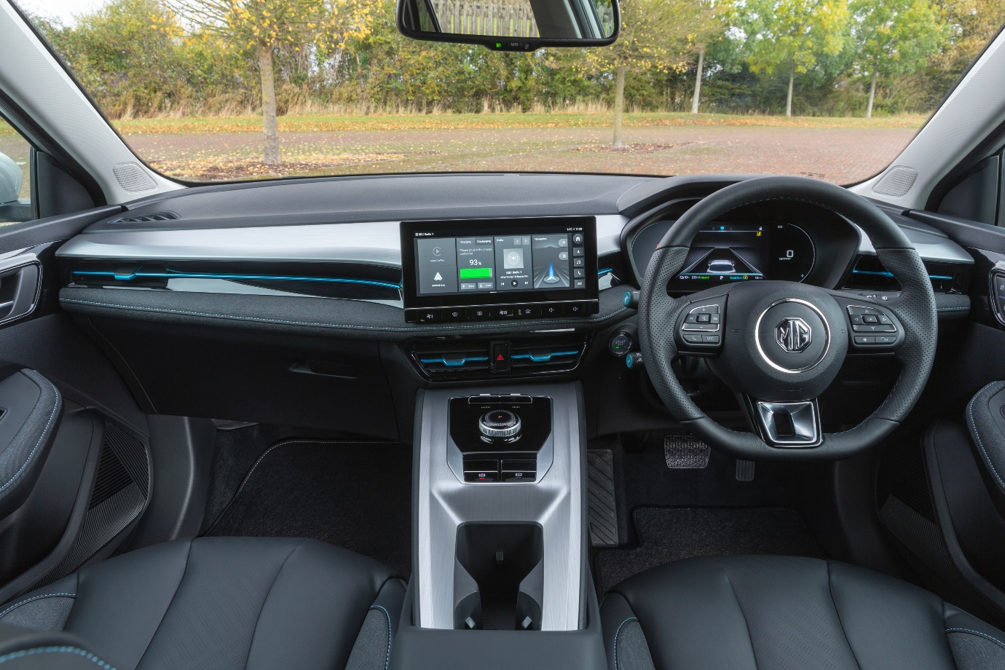

Model range specifications
 | MG5 EV SE | MG5 EV Trophy
Price from (OTR) | £30,995 | £33,495
Power (kW) | 115
Top speed (mph) | 115
0-62 mph (secs) | 7.7
Transmission / Drivetrain | Automatic 1 Speed / Front Wheel Drive
Combined WLTP range (miles) | 250 | 235
Nominal battery capacity (kWh) | 61.1
Charging from 10-80% on 150kW DC rapid charger (mins) | 35
Gross vehicle weight (kg) | 2028

Market comparison |  | 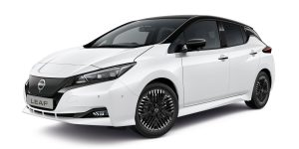 | 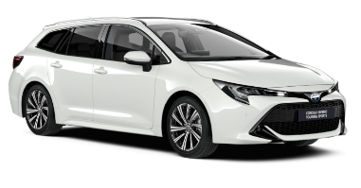
 | MG5 EV SE | Nissan LEAF Tekna | Toyota Corolla 1.8 Touring Sports Design Estate Hybrid
Price from (OTR) | £30,995 | £31,995 | £32,515
Power (kW) | 115 | 110 | 90
Top Speed (mph) | 115 | 90 | 111
0-62 mph (secs) | 7.7 | 7.9 | 11.1
Transmission / Drivetrain | 1 speed auto / FWD | 1 speed auto / FWD | 1 speed auto / FWD
Combined WLTP Range (miles) | 250 | 177 | N/A
Nominal Battery Capacity (kWh) | 61.1 | 39.0 | 1.4
Charging from 10-80% on 150kW DC rapid charger (mins) | 35 | N/A | N/A
Gross weight (kg) | 2,028 | 1,995 | 1,835
Luggage capacity (seats up) | 578 litres | 420 litres | 581 litres
Luggage capacity (seats down) | 1,367 litres | 1,176 litres | 1,606 litres
Benefit in kind rate / value (20%) | 2% / £124 | 2% / £130 | 27% / £1,743
Benefit in kind rate / value (40%) | 2% / £248 | 2% / £260 | 27% / £3,486
All product information gathered using verified source data. Prices as stated on manufacturer websites (valid as of 31st Oct 2022). BiK information generated via www.comcar.co.uk

Technical data | MG5 SE | MG5 Trophy
DRIVETRAIN & BATTERY
Maximum power | 156 PS | 156 PS
Maximum torque | 206 lb/ft | 206 lb/ft
Battery type | NCM (Nickel Cobalt Manganese) | NCM (Nickel Cobalt Manganese)
Battery capacity (nominal) | 61.1 kWh | 61.1 kWh
Battery capacity (usable) | 57.4 kWh | 57.4 kWh
PERFORMANCE
0-30mph | 3.2 secs | 3.2 secs
0-62mph | 7.7 secs | 7.7 secs
Maximum speed | 115 mph | 115 mph
EFFICIENCY
Max. driving range – Combined | 250 miles (403 km) | 235 miles (379 km)
CO₂ emissions | 0 g/km | 0 g/km
CHARGING
Charger Connection type | Combined Type 2 and CCS | Combined Type 2 and CCS
Maximum Rapid charging capability (DC) | 87 kW | 87 kW
Est. charging time (2.2 kW AC) 10-100% | 21 hrs | 21 hrs
Est. charging time (7 kW AC) 10-100% | 10 hrs | 10 hrs
Est. charging time (50 kW DC) 10-80% | 61 mins | 61 mins
Est. charging time (150 kW DC) 10-80% | 35 mins | 35 mins
WEIGHTS (kg)
Kerb weight | 1,552 | 1,560
Gross vehicle weight | 2,028 | 2,028
Max. towing weight (unbraked) | 500 | 500
Max. towing weight (braked) | 500 | 500
Gross train weight | 2,528 | 2,528
Max. tow ball weight | 50 | 50
Max. roof load | 75 | 75
DIMENSIONS
Overall length | 4,600 mm | 4,600 mm
Overall height (incl. roof rails) | 1,543 mm | 1,543 mm
Overall width (incl. mirrors) | 2,059 mm | 2,059 mm
Overall width (excl. mirrors) | 1,818 mm | 1,818 mm
Wheelbase | 2,659 mm | 2,659 mm
Front track | 1,558 mm | 1,558 mm
Rear track | 1,553 mm | 1,553 mm
Boot capacity – seats up/to luggage cover | 479 litres | 479 litres
Boot capacity – seats up/to roof | 578 litres | 578 litres
Boot capacity – seats down (excl. undertray) | 1,367 litres | 1,367 litres

 | Trim levels | MG5 EV SE | MG5 EV Trophy
Safety & Security | MG Pilot | l | l
 | ABS and EBD | l | l
 | Rear ISOFIX (x2) | l | l
 | Front Side Airbags | l | l
 | Front Dual Airbags | l | l
 | Side Curtain Airbag | l | l
 | TPMS | l | l
 | ESP | l | l
 | Hill Launch Assist | l | l
 | EBA | l | l
 | Driver's Seat Belt Reminder | l | l
 | Front and Rear Passenger's Seat Belt Reminder | l | l
 | Front Seat Belt (3 point with Pretensioner and Load Limiter) | l | l
 | Alarm & Engine Immobiliser | l | l
Vehicle Exterior | LED Headlights | l | l
 | LED Daytime Running Lights | l | l
 | Auto Headlights | l | l
 | LED Centre Brake Light | l | l
 | Follow me home headlights | l | l
 | Silver Roof Rails | l | l
 | Rear Parking Sensors | l | l
 | Electrically Adjustable, Manually Folding, Heated, Body Colour Door Mirrors | l
 | Electrically Adjustable & Folding, Heated, Body Colour Door Mirrors |  | l
 | Tinted Windows | l | l
 | Rear Privacy Glass |  | l
 | Front and Rear Aero Wiper | l | l
Wheels & Tyres | 16" Alloy Wheels 205/60 R16 with aero cover | l
 | 17" Alloy Wheels 215/50 R17 |  | l
 | Tyre Repair Kit | l | l
Seating | Fabric Upholstery | l
 | Leather Style Perforated Upholstery |  | l
 | Driver's 6-way Adjustable Seat | l
 | Electric Driver's 6-way Adjustable Seat |  | l
 | Passenger's 4-way Adjustable Seat | l | l
 | Driver's Seat Lumbar Adjustment | l | l
 | Heated Front Seats |  | l
 | Front Seat Back Map Pockets | l | l
 | 2nd Row 60:40 Split Fold Seat | l | l
 | Trim levels (continued) | MG5 EV SE | MG5 EV Trophy
Comfort & Convenience | Air Conditioning with odour filter | l
 | Auto Air Conditioning with odour filter |  | l
 | Smart Keyless Entry with Push Button Engine Start | l | l
 | Speed Sensing Locking | l | l
 | 7" Colour Driver Information Display | l | l
 | Rain Sensing Wipers |  | l
 | 12v Power Socket | l | l
 | Adaptive Cruise Control | l | l
 | Leather Steering Wheel | l | l
 | Height and Reach Adjustable Steering Wheel | l | l
 | Rotary Gear Selector | l | l
 | Electric Parking Brake with Auto-Hold | l | l
 | 3 Driving Modes (Eco, Normal, Sport) | l | l
 | 3 Regenerative Braking Modes (1, 2,3) | l | l
 | Vehicle to Load charging (max load 2200 watts) | l | l
 | Driver & Passenger Sun Visor with Mirror | l | l
 | Front & Rear Electric Windows with Driver's one-touch up/down | l
 | Front & Rear Electric Windows with Front & Rear one-touch up/down |  | l
 | Auto Dimming Rear View Mirror |  | l
 | Adjustable Dual-Height Boot Floor | l | l
In-Car Entertainment | 6-Speaker Audio System with 3D Sound | l | l
 | 4x USB Ports (2 front & 2 rear) | l | l
 | 10.25" Colour Touchscreen | l | l
 | DAB Audio | l | l
 | iSmart user app (includes Vehicle Status, Charging Management, WiFi) | l | l
 | Satellite Navigation | l | l
 | Apple CarPlay™ | l | l
 | Android Auto™ | l | l
 | Rear Parking Camera | l
 | 360° Parking Camera |  | l
 | Bluetooth Connection | l | l

About MG
MG is the fastest growing car brand in the UK, with a market-leading range of electric vehicles that are encouraging more drivers than ever to switch to zero-emission motoring.
Tracing its history back to 1924, MG is famous for building sporty, exciting and affordable cars. Today, the company is establishing itself as a driving force in the rapidly expanding UK electric car market, with a reputation for outstanding design, market-leading technology and excellent value for money.
Designed in Marylebone, London, and manufactured in state-of-the-art factories in several countries, today’s MGs are practical, spacious and packed with technology. From its innovative new Modular Scalable Platform (MSP) to the intelligent iSmart vehicle data app, MG continues to demonstrate a forward-thinking and progressive approach to the needs of today’s discerning motorists.
With a national network of over 150 dealerships, MG is accessible to customers everywhere with professional sales and aftersales provision across the UK. All new MGs are built with world-class components and are backed by a comprehensive manufacturer’s 7-year warranty.

