PRESS INFORMATION – Monday 18th March 2024

THE NEW MG3 HYBRID+ HAS ARRIVED
- All-new MG supermini arrives in the UK
- Pricing for SE and Trophy models announced
- Advanced Hybrid+ technology for great economy and lively MG performance
- A generously equipped, comfortable, modern and practical supermini from MG Motor

The all-new MG3 Hybrid+ supermini has arrived with MG Motor UK announcing pricing today and confirming that the MG3 is now available to order.
Both the SE and Trophy MG3 Hybrid+ models underline MG’s clear commitment to offering drivers exceptional value, with state-of-the-art hybrid technology available for a comparable price or less than many petrol superminis presently on sale in the UK.
The MG Hybrid+ SE starts from just £18,495 OTR with the even more generously equipped Trophy model available from £20,495 OTR. MG also offers a 7-year/80,000-mile warranty.
Like the award-winning MG4 EV hatchback, the MG3 Hybrid+ is set to impress with its generous equipment levels designed for safety, comfort and entertainment as standard.
Both MG3 Hybrid+ models come with dual screen technology, 16” alloy wheels, satellite navigation, Apple CarPlay/Android Auto, MG Pilot and a reversing camera. MG Pilot Safety includes Autonomous Emergency Braking (AEB), Front Collision Warning (FCW), Lane Departure Warning (LDW), Emergency Lane Keep Assist (LKAS) and Adaptive Cruise Control.
The Trophy MG3 Hybrid+ delivers even more comfort, style and convenience including a 360° camera, heated front seats and steering wheel, keyless entry, privacy glass, rain sensing wipers and LED projector headlights.
At the heart of the new MG3 is its highly efficient Hybrid+ powertrain which is poised to bring some enjoyable MG performance and verve to the supermini sector.
The combination of a larger than average battery (1.83kWh) and high-performance electric motor (100kW) enables the MG3 to go fully electric for city driving, which sets it apart from many other hybrid superminis. For longer journeys, there is the reassurance of a 1.5-litre petrol engine.
Advanced, smart features of Hybrid+ include a drive and charge system that allows the petrol engine to drive the wheels whilst also charging the battery through the generator.
The MG3 Hybrid+ returns impressive economy figures of 64.2mpg (4.4l/100km) and 100g/km of CO₂*.
Drivers can tailor the MG3’s responsiveness to their needs with the choice of three driving modes: Eco, Standard and Sport. Combined power is a class-leading 143kW giving the MG3 a sprightly 0-62mph time of 8.0 seconds. Mid-range acceleration is just as impressive, covering 50-70mph in just 5.0 seconds.
The MG3 Hybrid+ chassis and suspension has also been specifically tuned for UK roads – similar to the agile MG4 – by the company’s Longbridge-based engineering team.
David Allison, Head of Product and Planning for MG Motor UK, comments: “There is still a very strong demand for the affordable, practical and fun-to-drive supermini and we believe the MG3 Hybrid+ will appeal to many customers. Like all MG models, it will challenge the established superminis with its competitive price, whilst also delivering outstanding value with no compromises when it comes to equipment. We’re confident that if you simply wish to drive this MG for something other than daily commuting, it will offer a fun and involving experience.”
Full technical specifications and equipment specifications are provided below.
ENDS
Technical specifications
 | MG3 Hybrid+
Powertrain | Conventional Hybrid
Engine | 1.5-litre Atkinson-cycle four-cylinder petrol
Engine power (kW) | 75 (max)
Engine torque (Nm) | 128 (max)
Electric motor power (kW) | 100 (max)
Electric motor torque (Nm) | 250 (max)
Combined output – power (kW) | 143 (max)
Transmission | Three-speed automatic
Battery capacity | 1.83kWh – 350V
Driven wheels | Front
Max speed (km/h) | 170
0-100kph (seconds) | 8.0
CO2 (g/km) | 100* (subject to final approval)
Fuel economy (l/100km) | 4.4* (subject to final approval)
Height (mm) | 1,502
Length (mm) | 4,113
Width (mm) | 1,797
Wheelbase (mm) | 2,570
Kerb Weight (kg) | 1,298 (SE model)
Boot capacity (litres) | 293
No. of seats | 5

Equipment for SE and Trophy Models
 | MG3 Hybrid+ |  |  | SE |  | Trophy
 | OTR |  |  | £18,495 |  | £20,495
 | Safety & Security | MG Pilot
 |  | Adaptive Cruise Control |  | l |  | l
 |  | Active Emergency Braking with Pedestrian and Bicycle Detection |  | l |  | l
 |  | Lane Keep Assist (LKA) with Lane Departure Warning System (LDWS) |  | l |  | l
 |  | Traffic Jam Assist |  | l |  | l
 |  | Intelligent Speed Limit Assist |  | l |  | l
 |  | Rear Cross Traffic Alert |  |  |  | l
 |  | Blind Zone Detection with Lane Change Assist |  |  |  | l
 |  | Driver Attention Alert |  | l |  | l
 |  | Forward Collision Warning |  | l |  | l
 |  | Traffic Jam Assist |  | l |  | l
 |  | Electric Parking Brake with Autohold |  | l |  | l
 |  | ABS and EBD |  | l |  | l
 |  | Rear ISOFIX (x2) |  | l |  | l
 |  | Front Side Airbags |  | l |  | l
 |  | Front Dual Airbags |  | l |  | l
 |  | Front Passenger Airbag Deactivation Switch |  | l |  | l
 |  | Side Curtain Airbag |  | l |  | l
 |  | Tyre Pressure Monitoring System (TPMS) |  | l |  | l
 |  | ESP |  | l |  | l
 |  | Hill Start Assist |  | l |  | l
 |  | EBA |  | l |  | l
 |  | Driver's Seat Belt Reminder |  | l |  | l
 |  | Front and Rear Passenger's Seat Belt Reminder |  | l |  | l
 |  | Front Seat Belt (3 point with Pretensioner and Load Limiter) |  | l |  | l
 |  | Adjustable Rear Headrests |  | l |  | l
 |  | Alarm & Immobiliser |  | l |  | l
 | Vehicle Exterior | Halogen Projector Headlights |  | l
 |  | LED Projector Headlights |  |  |  | l
 |  | LED Daytime Running Lights |  | l |  | l
 |  | LED Centre Brake Light |  | l |  | l
 |  | Intelligent Headlamp Control |  | l |  | l
 |  | Automatic Headlamps |  | l |  | l
 |  | Follow Me Home Headlights |  | l |  | l
 |  | Rear Parking Sensors |  | l |  | l
 |  | Electrically Adjustable, Heated, Body Colour Door Mirrors |  | l |  | l
 | Wheels & Tyres | 16" "Atlas" Alloy Wheel |  | l |  | l
 |  | Tyre Repair Kit |  | l |  | l
 | Seating | Fabric Upholstery |  | l
 |  | Leather Style Upholstery with cloth inserts |  |  |  | l
 |  | Driver's 6-way Adjustable Seat |  | l |  | l
 |  | Passenger's 4-way Adjustable Seat |  | l |  | l
 |  | Front Passenger Seat Map Pocket |  |  |  | l
 | Comfort & Convenience | Air Conditioning |  | l |  | l
 |  | Remote Central Locking with Fold-away Key |  | l |  | l
 |  | Keyless Entry |  |  |  | l
 |  | Front & Rear Electric Windows with Driver's one touch up/down |  | l |  | l
 |  | Rear Privacy Glass |  |  |  | l
 |  | Rain Sensor Wiper |  |  |  | l
 |  | Rear Window Defogger |  | l |  | l
 |  | 12v Power Socket |  | l |  | l
 |  | Multifuctional Steering Wheel |  | l |  | l
 |  | Heated Front Seats |  |  |  | l
 |  | Heated Steering Wheel |  |  |  | l
 |  | Tilt Adjust Steering Column |  | l |  | l
 |  | Front Sun Visors with Driver and Passenger Mirrors |  | l |  | l
 |  | Front Cup Holder |  | l |  | l
 |  | Front Centre Armrest with Storage |  | l |  | l
 |  | Front Interior Courtesy Light with Time Delay and Reading Lights |  | l |  | l
 | In-Car Entertainment | 6-Speaker Audio System |  | l |  | l
 |  | Radio and AUX/USB, MP3 |  | l |  | l
 |  | x2 USB Ports at Front (x1 Functionality, x1 Charge) & X1 in rearview mirror |  | l |  | l
 |  | x1 USB Port at Rear (Charging Only) |  | l |  | l
 |  | DAB Audio |  | l |  | l
 |  | 7" Driver Display |  | l |  | l
 |  | 10.25" Colour Touchscreen |  | l |  | l
 |  | Satellite Navigation with Speed Limit Recognition |  | l |  | l
 |  | Apple CarPlay™ & Android Auto™ |  | l |  | l
 |  | Rear Parking Camera with sensor |  | l
 |  | 360° Camera with rear sensor |  |  |  | l
 |  | Bluetooth Connection |  | l |  | l
 |  | Trip Computer |  | l |  | l

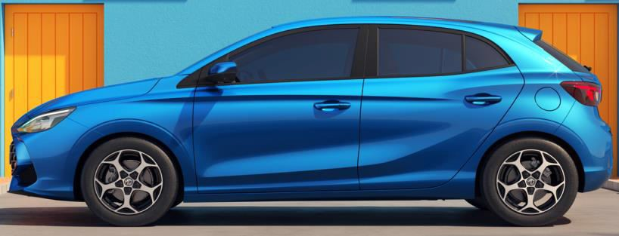
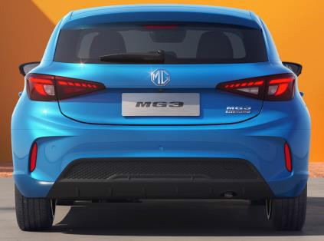
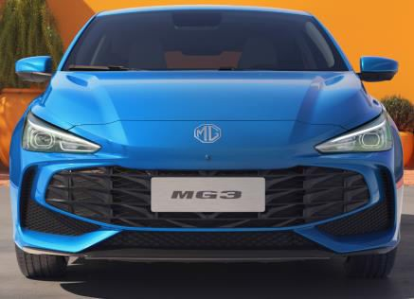
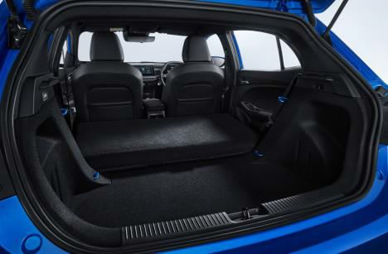
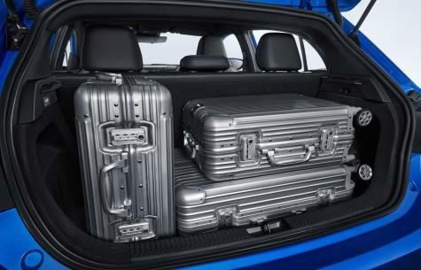
MG 3 Dimensions

Height 1502mm

Front Track 1510 mm Wheelbase 2570mm Rear Track 1520mm
Width 1797 mm Length 4113mm

Boot Capacity (seats up) 241 (brick) 293 (liquid) litres Boot Capacity (seats folded) 983 litres

About MG
Established in 1924, MG Motor boasts a storied legacy that spans a century. Our roots are deeply anchored in our maiden venture, the MG 14/28 Super Sports car, a masterpiece crafted by the iconic Cecil Kimber. Steeped in innovation and fuelled by a commitment to the future, our focus has shifted electrifyingly towards envisioning sustainable and accessible mobility for all.
Today, our values are reflected in the MG4 EV, an award-winning hatchback which underlines our commitment to delivering forward-thinking, technologically advanced and exhilarating electric vehicles.
MG Motor’s dedication is simple yet profound: democratising mobility. Our diverse lineup, featuring petrol, electric, and hybrid vehicles, encompasses versatile hatchbacks, functional station wagons, and spacious SUVs, all brimming with cutting-edge technology.
Every MG vehicle is a testament to world-class design and is reinforced by our generous 7-year/80,000-miles manufacturer's warranty.
Discover more about MG Motor, our range, and our expansive sales network by visiting our website at https://www.mg.co.uk/
For a detailed look into our vehicles, high-resolution imagery, and comprehensive specifications, please explore https://www.mg.co.uk/media-centre
MG Press Office
T: +44 (0)3301 756940
E: pr@mg.co.uk
www.mg.co.uk

